**A SMART FAULT REPORTING AND NOTIFICATON SYSTEM FOR EFFICIENT POWER DISTRIBUTION MANAGEMENT**

**CHAPTER 1**

1. **INTRODUCTION**

**1.1 Background of The Study**

Reliable electricity distribution is essential for economic growth and social well-being. According to Brew-Hammond (**2010**), inadequate power supply is a major barrier to industrial growth in many African countries, including Ghana.

In Ghana, (ECG) is responsible for power distribution in the southern part of the country. The Electricity Company of Ghana, which handles power distribution in the southern sector of the country, continues to face persistent challenges such as delayed fault responses and poor fault-tracking systems (Amankwah-Amoah, **2015**).

In recent years, several studies have explored the use of smart technologies to improve utility services. For instance, Agyekum et al. (**2021**) emphasized the need for integrating real-time reporting systems into national utility services to add to responsiveness and operational efficiency. Smart Fault Reporting and Notification Systems (SFRNS), as proposed in this project, aim to bridge the communication gap between utility providers and consumers while improving service delivery and fault management.

Ghana’s power distribution sector continues to grapple with challenges such as aging infrastructure, poor maintenance practices, and inefficient fault management systems. According to Gyamfi et al. (**2017**), many faults in the distribution network go unreported or are reported too late due to the reliance on manual fault-reporting methods. These delays hinder effective power restoration and negatively impact customer satisfaction.

With the rise of mobile technologies and smart systems, there is growing potential to change fault reporting in the power sector. Aboagye and Obeng-Darko (**2020**) argue that digital solutions can significantly reduce downtime by improving fault detection, reporting, and response processes. By implementing smart fault reporting systems, utility companies can overpass the communication space between consumers and providers, enabling real-time feedback and quicker intervention (Nyarko et al., 2022).

Power distribution is an essential component of any electricity supply system, ensuring that generated electricity holds out end-users efficiently and reliably. However, in Ghana, frequent faults in the power distribution network such as transformer failures, cable faults, and voltage fluctuations often lead to unplanned outages, causing inconvenience to consumers and financial losses to businesses (Adom et al., 2022). One of the key challenges in managing these faults is the lack of an efficient fault reporting and notification system, leading to delays in identifying, reporting, and resolving power-related issues (Mensah & Osei, 2021).

Currently, most fault reporting machines depend on manual complaints from consumers, which are often inefficient, as utility providers struggle to handle large volumes of reports and pinpoint fault locations accurately (Gyamfi et al., 2020). Additionally, the communication space between power companies, field engineers, and consumers further delays response times, leading to lengthen outages and customer dissatisfaction (Owusu & Boateng, 2019).

Electricity plays an important role in modern economic and social development, but power distribution challenges continue to hinder growth in many developing countries, including Ghana (Adom et al., 2022). Frequent power outages caused by faults in distribution networks not only disrupt businesses and households but also increase operational costs for utility providers (Mensah & Osei, 2021). One of the major challenges in fault management is the delay in fault reporting and inefficient communication between consumers, field engineers, and control centers (Gyamfi et al., 2020).

Traditionally, fault reporting depends on consumer complaints through call centers, which often leads to delayed responses due to high call volumes and lack of real-time monitoring (Owusu & Boateng, 2019). The absence of an automated fault detection and notification system further worsens the situation, as power companies struggle to pinpoint fault locations quickly and dispatch maintenance teams efficiently (Adebayo et al., 2023). Studies have shown that integrating smart monitoring systems can significantly improve response times and reduce outage durations (Kusi et al., 2021).

Recent advancements in IoT, cloud computing, and mobile technology provide an opportunity to develop an intelligent system that can automatically detect faults, report them in real time, and notify relevant participants through multiple communication channels (Asiedu & Amankwah, 2020). A smart fault reporting and notification system aims to bridge the space between power distribution companies and consumers by ensuring rapid fault detection, real-time reporting, and improved response times, leading to a more reliable and efficient power distribution network in Ghana (Ofori & Boadi, 2022).

**1.2 PROBLEM STATEMENT**

Traditional methods of reporting power faults in Ghana, such as call centers and physical office visits, are often inefficient and lead to delays in fault resolution. Customers lack a structured real-time means of reporting outages, while ECG struggles with effective fault-tracking and response prioritization. This study aims to address these challenges by designing an ICT-based fault reporting and notification system that enhances service delivery through automation, location tracking, and real-time updates.

The current fault reporting mechanisms within Ghana’s power distribution networks are mostly manual and reactive, resulting in delayed fault detection and prolonged power outages. Consumers often lack a direct and efficient channel to report faults, leading to communication breakdowns and inefficiencies in maintenance operations. This project addresses the need for a streamlined, technology-driven solution to enhance fault reporting and notification processes, thereby improving the reliability of power distribution.

The reliability of power distribution networks is essential for economic growth and societal well-being. However, frequent power outages caused by faults in the distribution system such as transformer failures, cable faults, and voltage fluctuations continue to disrupt businesses and households. One of the major challenges in managing these faults is the delay in fault detection, reporting, and resolution, which results in prolonged outages and increased operational costs for utility providers.

Currently, fault reporting relies heavily on manual consumer complaints through call centers, a process that is inefficient, time-consuming, and prone to human error. Utility companies often struggle to handle high volumes of complaints, leading to delays in identifying fault locations and dispatching maintenance teams. Additionally, the lack of an automated and real-time fault detection system prevents power providers from taking proactive measures to prevent faults or mitigate their impact.

The absence of an efficient fault reporting and notification system creates a communication gap between consumers, power companies, and field engineers, further exacerbating the response delay. This results in poor customer satisfaction, financial losses for businesses, and increased maintenance costs due to reactive rather than preventive fault management strategies.

**1.3 AIM OF THE PROJECT**

The main objective of this project is to develop and implement a smart fault reporting and notification system that enhances the efficiency, reliability, and safety of power distribution management through real-time monitoring and automated alerts.

**1.4 SPECIFIC PROJECT OBJECTIVES**

1. To develop a mobile and web-based application for electricity consumers to report real-time power-related faults.

2. To implement a GPS-based location tracking system for accurate fault localization.

3. To design a dashboard for the technician to track reported faults, assign response teams, and update customers on fault resolution progress.

4. To integrate automated notifications via SMS and push alerts to keep customers informed about complaint status.

**1.5** **SCOPE OF THE PROJECT**

The proposed system will:

1. Allow customers to report power faults via a mobile app, web platform, or USSD (for areas with limited internet access).

2. Send instant notifications via SMS, email, or app notifications to both users and field technicians.

3. Provide an admin dashboard for power distribution companies to manage, track, and resolve reported issues.

4. Support basic data analytics for predicting power failures and improving maintenance planning.

**1.6 PROJECT LIMITATIONS**

Despite the potential benefits of a Smart Fault Reporting and Notification System for efficient power distribution management, the project is subject to several limitations, including:

High Initial Implementation Cost: Deploying IoT sensors, cloud-based servers, and mobile notification systems involves significant financial investment in hardware, software, and infrastructure, which could be a barrier for power distribution companies with limited budgets.

Data Security and Privacy Risks: The system will collect and transmit real-time fault data, making it susceptible to cybersecurity threats, unauthorized access, or data breaches, which could compromise system reliability and user privacy.

Dependence on Stable Internet Connectivity: Since the system relies on cloud computing and real-time data transmission, unstable or slow internet connections, particularly in rural areas, could affect the accuracy and timeliness of fault notifications.

Integration with Existing Power Infrastructure: Many power distribution networks in Ghana use legacy systems that may not be easily compatible with modern IoT and cloud-based technologies, requiring additional investment in upgrades or middleware solutions.

Power Supply Issues – Ironically, the system itself depends on a stable power supply to function efficiently. Frequent power outages or fluctuations could disrupt the performance of IoT devices, communication networks, and cloud servers.

**1.7 ACADAMIC AND PRATICAL RELEVANCE OF THE PROJECT**

Academically, this project contributes to the field of smart grid technologies and information systems by demonstrating the application of mobile technology in utility management. Practically, it offers a tangible solution to enhance the efficiency of power distribution management in Ghana, potentially serving as a model for similar contexts in other developing countries.

**1.8 BENEFICIARIES OF THE PROJECT**

1. Electricity Consumers: Gain a direct and efficient channel to report faults, leading to improved service satisfaction.
2. Power Distribution Companies: Benefit from streamlined fault management processes, reduced outage durations, and enhanced operational efficiency.
3. Maintenance Teams: Receive timely notifications and detailed fault information, facilitating quicker and more effective responses.
4. Policymakers and Regulators: Obtain data-driven insights into power distribution challenges, informing policy decisions and regulatory measures.

**1.9 PROJECT ACTIVITY PLANNING**

To effectively plan and execute the Smart Fault Reporting and Notification System (SFRNS) project, a Gantt Chart will be used as the project management tool. The following table outlines the key activities, their timelines, and responsible parties:

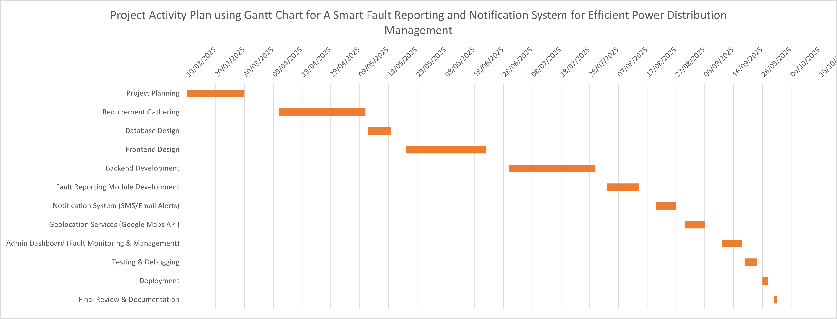

The project follows an Agile Development Approach, ensuring flexibility in iterations, continuous feedback, and improvement throughout the development lifecycle.

**1.10 DEFINITIONS AND EXPLANATIONS OF TERMS**

1. Fault Reporting: The process of notifying utility providers about power distribution failures for prompt resolution.

2. Notification System: A mechanism that automatically informs relevant stakeholders (customers, engineers, ECG officials) about reported faults and resolutions.

3. IoT (Internet of Things): A network of connected devices that collect and exchange data, used here for fault detection and reporting.

4. Cloud Computing: Remote servers storing and processing system data, ensuring seamless access and scalability.

5. GPS Tracking System: A satellite-based technology used to determine the location of reported power faults in real time.

6. Smart Grid: A modernized power distribution network using digital technologies to enhance efficiency, reliability, and sustainability.

7. Push Notifications: Automated messages sent to users via mobile or web applications to inform them about updates related to fault reporting.

8. Dashboard: A graphical interface displaying fault reports, response progress, and analytics for ECG officials.

9. USSD (Unstructured Supplementary Service Data): A technology allowing consumers to report faults through simple text-based commands without internet access.

10. Reactive vs Preventive Maintenance: Reactive maintenance addresses faults after they occur, whereas preventive maintenance aims to identify and resolve potential issues before failures happen.

**1.11 STRUCTURE OF THE REPORT**

The project report will be organized into the following chapters:

Chapter 1: Introduction

1. Background of the Study
2. Problem Statement
3. Aim of the Project
4. Specific Objectives
5. Scope of the Project
6. Project Limitations
7. Academic and Practical Relevance
8. Beneficiaries

Chapter 2: Literature Review

1. Overview of Power Distribution Challenges
2. Existing Fault Reporting Systems
3. Smart Grid Technologies and IoT Applications
4. Related Works and Case Studies
5. Research Gaps

Chapter 3: Methodology

1. System Development Approach (Agile, Waterfall, etc.)
2. Data Collection Methods
3. System Design Architecture
4. Hardware and Software Requirements
5. Testing and Validation Techniques

Chapter 4: System Implementation and Results

1. System Features and Functionality
2. User Interface and Experience
3. Backend and Database Implementation
4. Fault Reporting Process Flow
5. Testing and Performance Analysis

Chapter 5: Conclusion and Recommendations

1. Summary of Findings
2. System Effectiveness
3. Challenges Faced
4. Future Enhancements

The structured approach ensures a clear and comprehensive presentation of the research, design, implementation, and evaluation of the Smart Fault Reporting and Notification System.

**1.12 ORGANIZATION OF THE STUDY**

This study is organized into five comprehensive chapters, each structured to provide clarity and logical flow throughout the research process:

1. Chapter One: Introduction

This chapter introduces the background and context of the study, highlighting the challenges associated with fault management in Ghana’s power distribution system. It outlines the problem statement, aims, objectives, scope, limitations, academic and practical relevance, project beneficiaries, and key definitions.

1. Chapter Two: Literature Review

This chapter presents a detailed review of relevant literature, including existing fault reporting systems, smart grid technologies, and case studies on similar implementations. It identifies knowledge gaps and justifies the need for the proposed Smart Fault Reporting and Notification System (SFRNS).

1. Chapter Three: Methodology

This chapter outlines the research and system development approach used for the project. It describes the system design architecture, data collection methods, technology stack, testing procedures, and justification for the selected methodology.

1. Chapter Four: System Implementation and Results

This chapter provides a practical breakdown of the developed system, covering both front-end and back-end components. It includes user interface design, system functionality, fault reporting workflows, testing outcomes, and performance analysis.

1. Chapter Five: Conclusion and Recommendations

This final chapter summarizes the key findings of the project, evaluates the effectiveness of the developed system, discusses encountered challenges, and suggests areas for future research and enhancement.

**1.13 CONCLUSION**

This chapter has laid the foundation for the development of a Smart Fault Reporting and Notification System (SFRNS) tailored to the needs of Ghana’s power distribution sector. It has provided a comprehensive overview of the challenges currently facing fault management processes, particularly the inefficiencies caused by manual reporting methods and delayed responses. The background, problem statement, and project objectives emphasize the urgent need for a more efficient, real-time, and technology-driven solution.

By leveraging smart technologies such as IoT, GPS, and mobile applications, the proposed system aims to transform fault detection, reporting, and resolution processes, thereby enhancing the reliability of electricity distribution. The chapter has also outlined the scope, limitations, academic relevance, and key beneficiaries of the project, highlighting its practical value and broader societal impact. The next chapter will delve into related literature, exploring existing systems, technological trends, and research gaps that this project seeks to address.

**CHAPTER TWO**

**2.0 INTRODUCTION**

This chapter presents a review of existing literature related to fault detection, reporting, and notification systems within the domain of power distribution. It explores previous research efforts, existing technologies, and methodologies that have been implemented to address challenges in electrical fault management. The review provides insights into smart grid technologies, fault diagnosis techniques, real-time monitoring systems, and mobile-based reporting tools. By analyzing the strengths and limitations of existing systems, this chapter aims to highlight the research gaps and justify the need for a smart fault reporting and notification system tailored to the Ghanaian power distribution context. The literature review also forms the theoretical foundation upon which the proposed system is developed.

**2.1 REVIEW OF RELATED LITERATURE**

Researchers and practitioners have developed numerous solutions to improve the reliability of power distribution networks. Many of these solutions incorporate technologies such as the Internet of Things (IoT), mobile applications, and Geographic Information Systems (GIS) to monitor and detect faults in real time.

For instance, Okafor et al. (2019) proposed a mobile-based fault detection system that uses SMS notifications to alert technicians of faults. Their study showed a significant improvement in fault response time. Similarly, Ahmed and Musa (2021) introduced an IoT-enabled model for real-time monitoring and fault isolation in rural power lines, allowing quicker fault diagnosis and restoration.

Other researchers have focused on customer involvement. A study by Mensah and Boateng (2020) emphasized the role of end-users in reporting power issues using mobile applications, which bridge the communication gap between utility companies and consumers.

While these efforts are commendable, most of them were implemented in regions with reliable internet access and technical infrastructure, which may not reflect the conditions in many parts of Ghana. Furthermore, few studies have explored the integration of fault reporting with automated location tracking and notification systems, which are crucial for rapid fault resolution in power distribution networks.

**2.2 REVIEW OF EXISTING SYSTEMS**

Several fault detection and management systems have been implemented globally and within Africa to address challenges in power distribution networks. These systems vary in complexity, technology, and accessibility, depending on the region and infrastructure in place. This section highlights some notable systems and evaluates their relevance to the Ghanaian context.

**2.2.1 FAULT MANAGEMENT SYSTEM – KENYA POWER**

Kenya Power developed an online Fault Management System (FMS) to improve the reporting and resolution of electrical faults. The system enables users to report faults through a web portal and also supports internal logging by field technicians. The FMS features a centralized dashboard that tracks reported issues, their resolution status, and technician response times. While the system improved efficiency and accountability, its heavy reliance on internet access and technical know-how limits its use in rural areas.

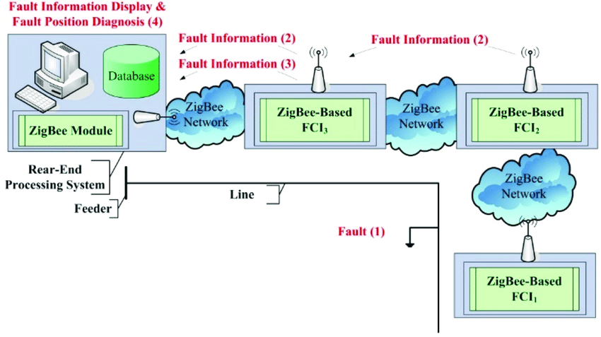

Fig.2.2.2. Basic concept of a Fault Management System (FMS).

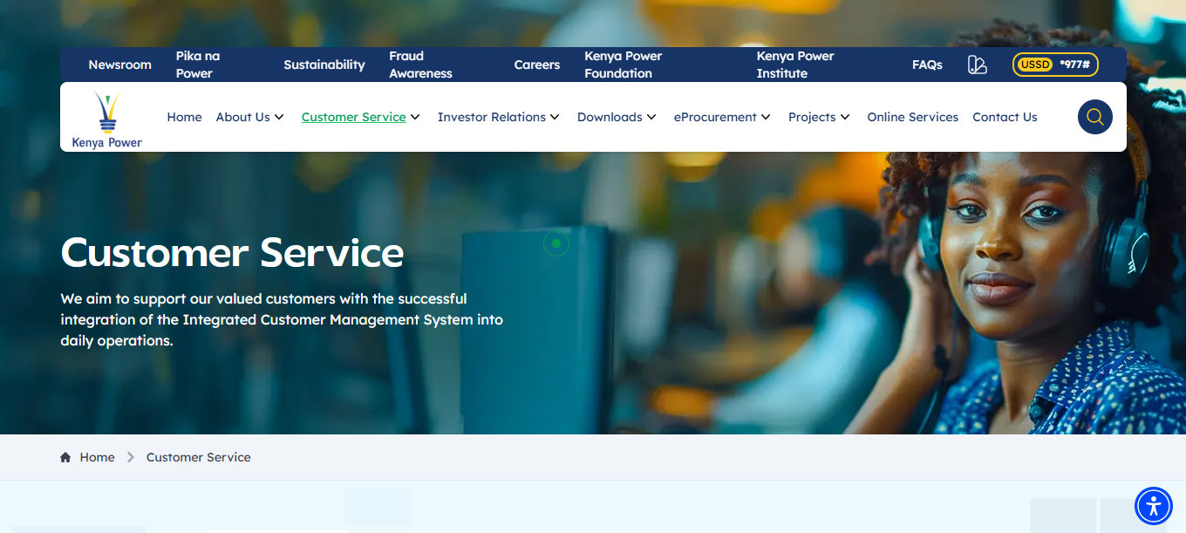

Fig.2.2.3. Home page of FMS

**2.2.4 USE CASE DIAGRAM FOR FMS**

The diagram illustrates a Fault Management System where three main actors, User, Technician, and Admin interact with the system through various functions. Users can register, log in, report faults, buy credit, view fault status, and receive updates. Technicians log in to access reported faults, update fault details, and communicate status. Admins oversee the system, log in, and receive notifications. All activities are connected to a central Database, which stores and manages information such as user data, fault reports, and credit transactions.

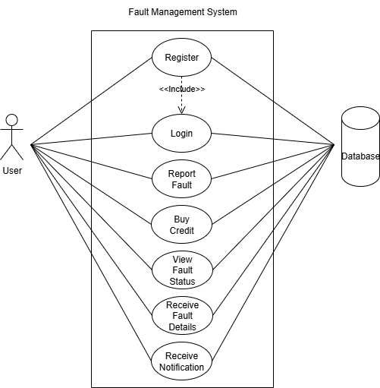

Fig.2.2.5. A Use Case Diagram on FMS

**2.2.6. A CLASS DIAGRAM FOR FMS**

This is a UML Class Diagram for a Fault Management System (FMS). It represents the static structure of the system by showing the system’s classes, their attributes, and how they relate to one another.

This is a UML Class Diagram for a Fault Management System (FMS). It shows the main components of the system and their attributes:

1. Customer: Reports faults (has customerID, name).
2. FaultReport: Stores fault details (reportID, description, timestamp, status).
3. Technician: Assigned to resolve faults (technicianID, name, phone).
4. Location: Specifies where the fault occurred (latitude, longitude).
5. TaultReport (likely a typo): Holds notification data (notificationID, message).
6. Notification: Sends messages to users (notificationID, message).

Each rectangle represents a class, and though relationships aren’t drawn, they should connect based on how data flows between customers, faults, technicians, and notifications.

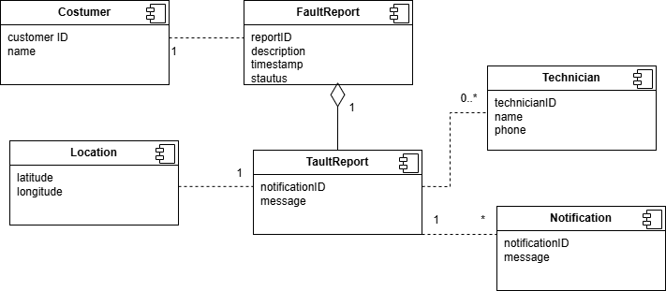

Fig.2.2.7. A Class Diagram on FMS

**2.2.8. A CONTEXT DIAGRAM FOR FMS**

This diagram is a context-level Data Flow Diagram (DFD) for a Fault Management System, which shows how information flows between the system and its external entities.

The diagram shows how a Fault Management System interacts with key external entities:

1. Customers report faults and receive updates.
2. The Operation Center monitors and manages fault activities.
3. Technicians get fault assignments and provide updates.
4. A Database stores and retrieves all fault-related data.

The system acts as a central hub, coordinating fault reporting, resolution, and communication between all parties.

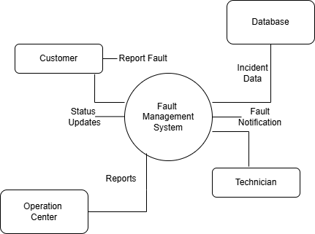

Fig.2.2.9. A Context Diagram on FMS

**2.3.0. SEQUENCE DIAGRAM FOR FMS**

This is a UML Sequence Diagram showing the end‑to‑end flow of a fault report through the Fault Management System (FMS).

Actors: Customer, Fault Management System (FMS), Technician, Operation Center (plus an implied Database).

1. Customer → FMS: Reports a fault.

2. FMS ↔ Database: Stores the fault and gets confirmation.

3. FMS → Operation Center: Notifies ops team of the new fault.

4. FMS → Technician: Assigns the fault.

5. Technician → FMS: Accepts assignment.

6. Technician → FMS: Sends status updates (“In progress,” “Resolved”).

7. FMS ↔ Database: Persists each status update.

8. FMS → Customer: Sends the latest fault-status notification.

The FMS orchestrates fault reporting, storage, dispatch, status tracking, and customer updates, with confirmations at each critical step.

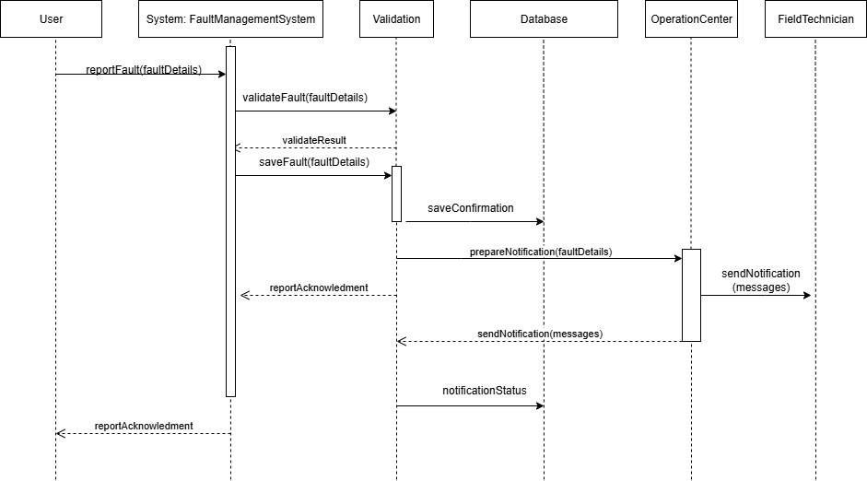

Fig.2.3.1. A Sequence Diagram on FMS

The FMS orchestrates fault reporting, storage, dispatch, status tracking, and customer updates, with confirmations at each critical step.

**2.3.2. STRENGTH OF THE SYSTEM**

1. Centralized fault logging and tracking system.

2. Real-time status monitoring for technicians and supervisors.

3. Enhanced accountability through system-generated fault history and response time tracking.

4. Improved transparency between departments handling fault resolution.

**2.3.3. WEAKNESS OF THE SYSTEM**

1. High dependency on internet connectivity, limiting usability in rural/remote areas.

2. Not user-friendly for customers with low digital literacy.

3. Primarily used internally limited direct customer engagement.

4. Requires a stable infrastructure and trained personnel to operate effectively.

**2.3.4. ECG MOBILE APP FAULT REPORTING SYSTEM**

The Electricity Company of Ghana (ECG) introduced a mobile application that allows users to report faults, track prepaid meter usage, and make payments. The app includes a fault reporting feature that lets customers submit complaints, which are then processed by ECG personnel. While this app has improved customer engagement, it still faces limitations such as delayed response times, lack of real-time updates on reported issues, and dependency on internet connectivity. Moreover, it lacks a robust back-end system for automatic fault classification and technician assignment.

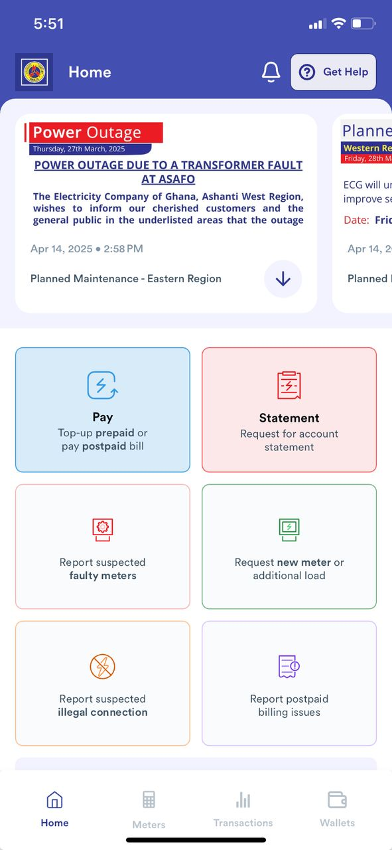

Fig.2.3.5. Home Page of ECG App

**2.3.6. SEQUENCE DIAGRAM FOR ECG**

A sequence diagram shows the step-by-step interactions between different entities (called lifelines) in a system over time. It helps illustrate how a process or functionality flows, particularly focusing on how messages are passed between the entities.

The diagram represents the sequence of events in a smart fault reporting and notification system, used by customers and technicians to efficiently manage electrical faults reported to the Electricity Company of Ghana (ECG). The process begins with the Customer, who detects a fault and uses the ECG Mobile App to report it. Once the report is submitted, the app sends the information to the ECG Backend, which handles the core processing logic of the system.

The backend then stores the fault information into the Database for record-keeping and further analysis. After saving the fault details, the backend system assigns the fault to an available Technician for inspection and resolution.

To inform the technician of the new assignment, the system sends a Notification, which alerts the technician about the reported fault and its location. Upon receiving the notification, the Technician acknowledges it and proceeds to the reported site for inspection and further action.

This automated flow helps ECG to:

1. Quickly capture customer fault reports.
2. Efficiently assign tasks to technicians.
3. Notify technicians without delay.
4. Ensure technicians respond promptly to faults.

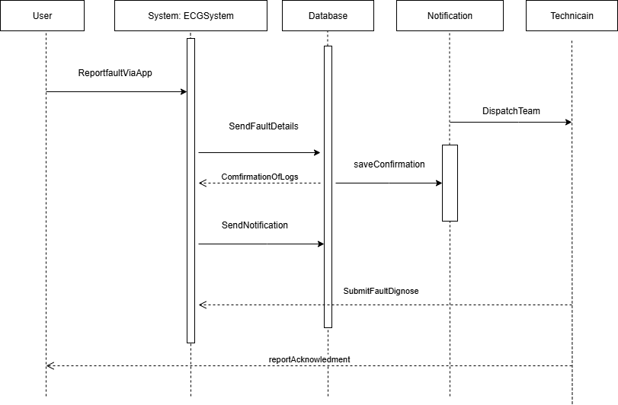

Fig.2.3.7 A Sequence Diagram for ECG

**2.3.8. A CONTEXT DIAGRAM FOR ECG**

The diagram is a use case diagram for an ECG Management System, showing how a customer interacts with the system. The customer can:

1. Buy electricity credit
2. Check transactions
3. Request services
4. Pay bills
5. Manage users

It visually represents the main functions the system offers to its users.

Actors:

1. Customer: The external user (actor) interacting with the system. The customer is the one who performs various activities or “use cases” within the ECG system.

Use Cases (Functions the customer can perform):

1. Buy Credit: The customer can purchase electricity credit through the system.

2. heck Transactions: The customer can view past transactions, such as credit purchases or bill payments.

3. Request Service: The customer can make service-related requests (e.g., report faults, request new meter installation, etc.).

4. Pay Bill: The customer can pay electricity bills online or through the system.

5. Manage Users: This likely refers to an administrative capability or role where user accounts (possibly other customers or staff) can be managed.

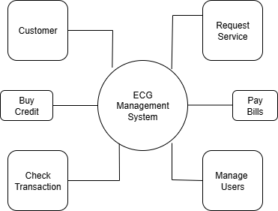

Fig.2.3.9. A Context Diagram for ECG

**2.4.0. A USE CASE DIAGRAM FOR ECG**

A use case diagram is used to visually represent the interactions between users (actors) and a system. It shows what the system does (its functionalities) from the user’s perspective, not how it does it. The diagram illustrates ECG Mobile application where users can register, log in, report faults, buy credit, and receive updates. Admins manage user data, verify faults, and send notifications, while technicians handle fault repairs and update statuses. All interactions are linked to a central database to ensure efficient communication and power distribution management.

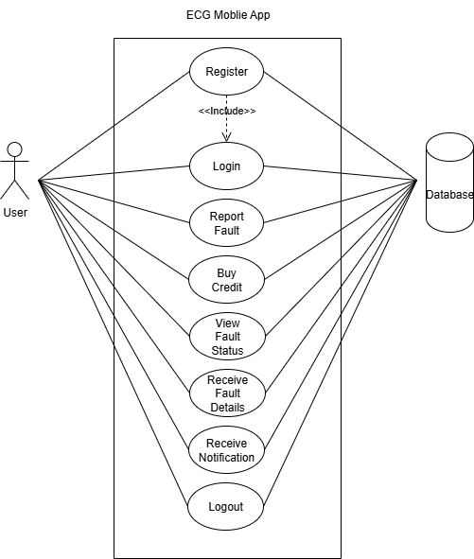

Fig.2.4.1**.** A Use Case Diagram for ECG

**2.4.2. A CLASS DIAGRAM FOR FMS**

This is a UML Class Diagram for a Fault Management System (FMS). It represents the static structure of the system by showing the system’s classes, their attributes, and how they relate to one another.

This is a UML Class Diagram for a Fault Management System (FMS). It shows the main components of the system and their attributes:

1. Customer: Reports faults (has customerID, name).
2. Fault: Stores fault details (faultID, description, timestamp, status).
3. Technician: Assigned to resolve faults (technicianID, name, status).
4. Bill: the statement of how much you owe the E (ECG) for electricity usage (billID, generatebill)

Each rectangle represents a class, and though relationships aren’t drawn, they should connect based on how data flows between customers, faults, technicians, and bill.

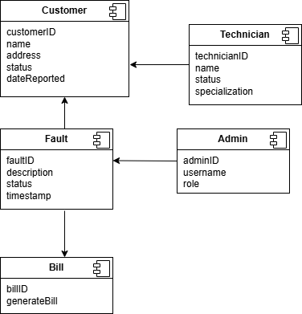

Fig.2.4.3**.** A Class Diagram for ECG

**2.4.4. STRENGTH OF THE SYSTEM**

1. Enables customers to report faults directly from their mobile phones.

2. Integrated with prepaid services and bill payment features.

3. Improves communication between ECG and consumers.

4. Increases convenience and reduces the need for physical visits to ECG offices.

**2.3.3. WEAKNESS OF THE SYSTEM**

1. Heavily reliant on internet access, limiting functionality in low-connectivity areas.

2. No real-time feedback or updates after fault submission.

3. Lacks technician dispatch integration or automatic fault prioritization.

4. Some users report delays in response and resolution of reported issues.

**2.3. 4.** **SMART GRID FAULT DETECTION AND ISOLATION SYSTEM**

Smart grid systems use advanced sensors, automation, and communication technologies to detect and isolate faults in real-time. These systems can automatically reroute power and restore supply without manual intervention. A typical Smart Grid Fault Detection and Isolation System integrates Supervisory Control and Data Acquisition (SCADA), Phasor Measurement Units (PMUs), and smart meters to provide a self-healing grid. However, these systems are often costly and complex, requiring significant investment and infrastructure, making them less feasible for developing countries like Ghana at scale.

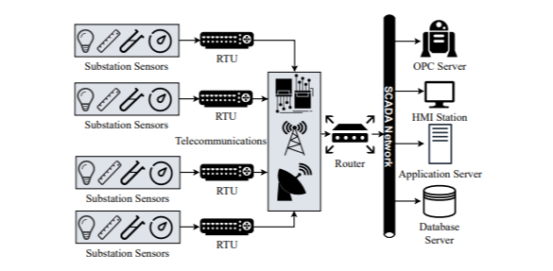

Fig.2.3.5. SCADA Network Architecture for SG System

**2.3.6. A SEQUENCE DIAGRAM ON SMART GRID FAULT DETECTION AND ISOLATION SYSTEM.**

The sequence diagram illustrates how the Smart Grid Fault Detection and Isolation System operates when a fault occurs. A sensor first detects the fault and sends a signal to the fault detection system, which analyzes and isolates the faulty section to prevent further issues. The system then notifies the control center operator, who dispatches a maintenance team to repair the fault. This process ensures quick fault detection, isolation, and resolution, minimizing power outages and improving the grid’s reliability.

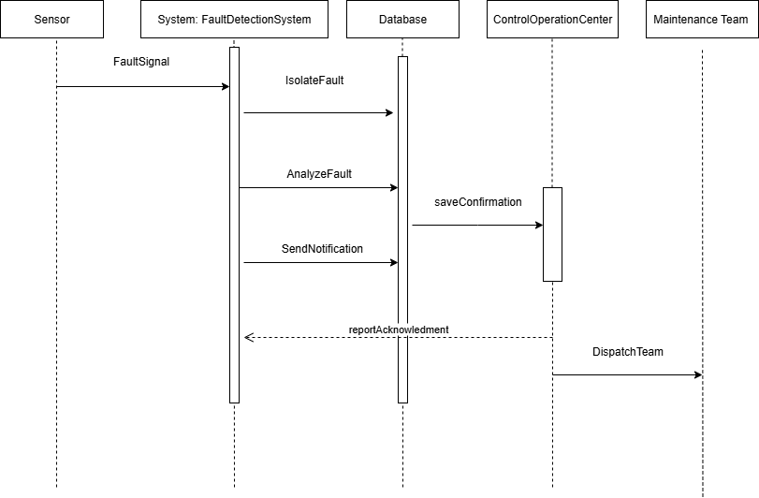

Fig.2.3.7. A Sequence Diagram on SG

**2.4.8. A USE CASE DIAGRAM FOR SMART GRID FAULT DETECTION AND ISOLATION SYSTEM.**

This diagram represents the functionalities of the system and how various actors interact with it.

Actors:

1. Grid Operator: The main user of the system who interacts with different features.
2. Admin: Manages user accounts and permissions.

Use Cases (Functions):

1. Monitor Grid: The operator continuously monitors grid performance.
2. Detect Faulty Report: The system automatically detects and logs faults in the power grid.
3. Notify Maintenance Team: Sends automated notifications to the maintenance team when a fault is detected.
4. View Fault Report: Allows operators or admins to view detailed reports on faults.
5. Manage Users: Admin function to add/remove or update user accounts.

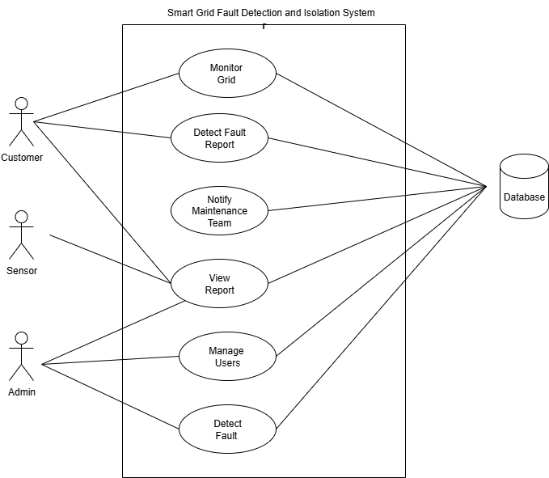

Fig.2.3.9. A Use Case Diagram on SG

* + 1. **A CLASS DIAGRAM FOR SMART GRID FAULT DETECTION AND ISOLATION SYSTEM.**

This is a UML Class Diagram for Smart Grid Fault Detection and Isolation System. It represents the static structure of the system by showing the system’s classes, their attributes, and how they relate to one another.

This is a UML Class Diagram for Smart Grid Fault Detection and Isolation System. It shows the main components of the system and their attributes:

1. Sensor: Reports faults (has sensorID, status).
2. Fault: Stores fault details (faultID, type, timestamp, location).
3. Grid Operator: Assigned to resolve faults (operatorID, name).
4. Maintenance Team: Detect fault reports (teamID, teamName)

Each rectangle represents a class, and though relationships aren’t drawn, they should connect based on how data flows between sensor, fault, grid operator, and maintenance team.

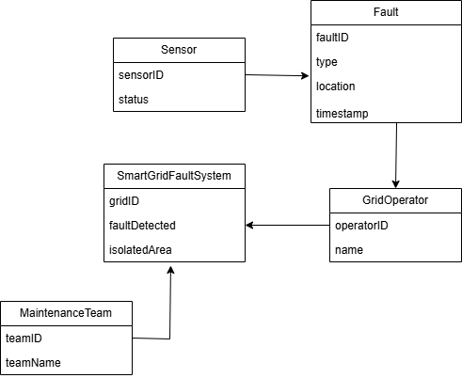

Fig.2.4.1. A Class Diagram on SG

**2.4.2. A CONTEXT DIAGRAM FOR SMART GRID FAULT DETECTION AND ISOLATION SYSTEM.**

This diagram shows the system as a single process block and its interactions with external entities.

System: Smart Grid Fault Detection and Isolation System

External Entities:

1. Sensor Device: Sends data about the grid’s condition to the system.
2. Grid Operator: Views reports and makes decisions based on system output.
3. Maintenance Team: Receives fault alerts and acts on them.
4. External System: Could be other integrated tools or software (e.g., GIS, reporting dashboards).

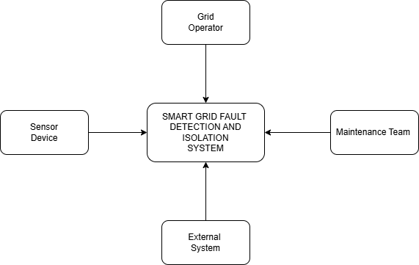

Fig.2.4.3. A Context Diagram on SG

**2.4.4. STRENGTH OF THE SYSTEM**

1. Real-time fault detection and automatic isolation for rapid fault response.

2. Supports self-healing capabilities in advanced grids.

3. Reduces downtime and improves reliability of power supply.

4. Enables proactive maintenance through predictive analytics.

**2.4.5. WEAKNESS OF THE SYSTEM**

1. Very costly to implement and maintain, especially for developing countries.

2. Requires a highly digitized power infrastructure and skilled workforce.

3. Not accessible to end-users or consumers for reporting purposes.

4. Infrastructure-intensive and may not be scalable across less developed regions.

**2.4.6. DIFFERENCES BETWEEN EXISTING SYSTEMS AND THE PROPOSED SYSTEM**

|  |  |  |
| --- | --- | --- |
| **FEATURE** | **EXISTING SYSTEM** | **PROPOSED SYSTEM** |
| Internet Dependency | Heavily reliant on internet access (Okafor et al, 2019; ECG, 2020) | Designed to work both online and offline (e.g., SMS-base reporting) |
| User Engagement | Limited or one one-way (Mensah & Boateng) | Real-time two-way communication between user and utility provider |
| Fault Localization | Often manual or based on user descriptions (Kenya Power, 2021) | GPS-enabled fault reporting for accurate location tracking |
| Automation | Mostly manual technician dispatch (ECG, 2022) | Automated fault classification and technician assignment |
| Infrastructure Cost | High (especially for Smart Grid system) (Ahmed & Musa, 2021) | Cost-effective, using mobile and cloud-based technologies |
| Accessibility | Not user-friendly for all (Mensah & Boateng, 2020) | Easy-to-use interface for both technical and non-technical users |
| Notification System | Basic or absent (Kenya Power, 2021) | Automatic SMS/Push notification to users and technicians |
| Power Restoration Tracking | Not integrated or available (Okafor et al, 2019) | Tracks reported faults, technician response, and  restoration updates |
| Target Users | Mostly internal or urban users (Kenya Power, 2021) | Designed for both internal use and public use, including rural areas |

**2. 4.7. REFERENCES**

1. Ahmed, K., & Musa, S. (2021). IoT-Based Smart Grid Fault Detection and Monitoring Systems: A Case Study. International Journal of Electrical Engineering, 13(2), 55–64.

2. ECG. (2022). ECG Mobile App Overview. Electricity Company of Ghana. Retrieved from https://ecggh.com

3. Kenya Power. (2021). Fault Management System (FMS) Overview. Kenya Power & Lighting Company. Retrieved from https://kplc.co.ke

4. Mensah, K., & Boateng, D. (2020). Improving Customer-Fault Reporting in Power Distribution: A Mobile-Based Approach. Journal of Energy and ICT Development, 4(1), 12–20.

5. Okafor, J., Nwosu, E., & Chukwuma, A. (2019). Development of an SMS-Based Fault Reporting System for Urban Power Distribution. International Journal of Engineering Research, 8(3), 102–108.

**2.4.8. CONCLUSION**

This chapter has reviewed relevant literature and existing systems on fault detection, reporting, and notification within the power distribution sector. It explored scholarly works that discuss mobile-based fault reporting, smart grid technologies, and IoT-driven fault isolation. Additionally, existing systems such as the Kenya Power Fault Management System, Smart Grid models, and the ECG Mobile App were analyzed in terms of their functionality, strengths, and weaknesses.

The review revealed that while these systems have made significant progress in improving fault response and management, they often face challenges such as high cost, lack of offline accessibility, limited user interaction, and poor adaptation to local conditions in developing countries like Ghana. These gaps highlight the need for a more inclusive, affordable, and efficient solution.

The proposed Smart Fault Reporting and Notification System seeks to address these limitations by offering real-time fault reporting, two-way communication, location tracking, and notification capabilities, tailored to Ghana’s power distribution landscape. This sets the foundation for the next chapter, which focuses on the system’s design and methodology.

**CHAPTER THREE**

**METHODOLOGY**

**3. 0 INTRODUCTION**

This chapter outlines the methodology adopted for the design and development of the Smart Fault Reporting and Notification System for Efficient Power Distribution Management in Ghana. The approach employed for this project is the Agile software development methodology, which emphasizes iterative development, continuous feedback, and collaboration between developers and stakeholders.

The Agile methodology was chosen due to its flexibility and ability to adapt to changing requirements throughout the project lifecycle. Given the dynamic nature of fault management in power distribution, Agile provided a structured yet adaptable framework to incrementally develop system features while ensuring that user needs remained a top priority.

The chapter discusses the various phases involved in the development process, including requirements gathering, sprint planning, system design, implementation, testing, and evaluation. It also explains the data collection methods, tools, and technologies used in building the system. Each sprint cycle allowed for testing, feedback, and refinement, ensuring that the final system is functional, user-friendly, and aligned with real-world needs in Ghana’s power distribution sector.

By using Agile, the project team was able to maintain flexibility, engage stakeholders early and often, and deliver a high-quality software solution capable of enhancing the efficiency of fault reporting and response mechanisms within the power sector.

**3.1 SOFTWARE DEVELOPMENT PROCESS MODEL USED**

The agile methodology approach from the Software Development Life Cycle (S.D.L.C) will be deployed in the entire development process. It is one of the best S.D.L.C models to use when developing systems because it breaks the task into smaller iterations. The project scope and requirements are laid down at the beginning of the development process. This type of model is used to ensure flexibility in terms of making any changes to the system when necessary since it breaks the various tasks into smaller projects.

(Agile Model (Software Engineering) - Java point, n.d.) The agile methodology uses an adaptive approach where there is no precise planning and there is only clarity on the future tasks only in consideration of what features need to be progressed. When there is a feature- driven development, the team adapts to the changing product requirements mightily. The project deliverable is then tested very often, through the release iterations, minimizing the risk of any major failures in the future.

**3.2 JUSTIFICATION FOR CHOOSING AGILE METHODOLOGY**

The Agile Methodology under the System Development Life Cycle consists of four fundamental phases: planning, analysis, design and implementation.

It is an appropriate methodology for software or project development because it breaks project components into smaller parts and developed incrementally over time.

Again, the agile methodology is very flexible and allows customization of system components to allow the system suit end – user needs, it is important to note that clients or end user involvement is key to the development process.

Major system requirements can change and easily implemented at any phase of the development process as compare to other development process which have a more rigid approach of not being able to respond to requirement changes.

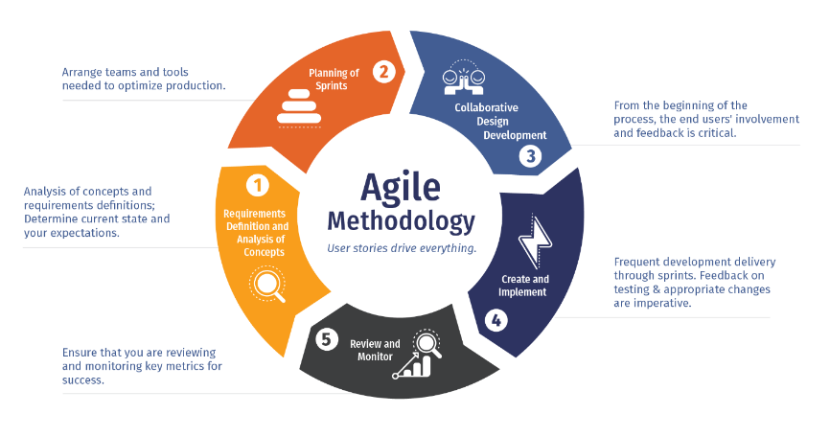

**DETAILED DESCRIPTION OF ACTIVITIES UNDER EACH PHASE**

**PLANNING PHASE**

The diagram below depicts the numerous activities that will be undertaken to ensure a successful completion of this project. Each activity has been structured out with start and end dates highlighting the duration it will take for each activity to be undertaken. The Gantt chart as a project management tool will ensure that project timelines and deliverables are met within the stipulated time.



Fig. A Gantt Chart representing set of activities for this project

**ANALYSIS PHASE**

Under this phase, feasibility studies were conducted to understand the associated risk, cost with the development of this project. Requirement gathering as a key component of software development was incorporated by using interviews as a data collection method to know what students want and how they will like the system to work in order to suit their needs.

The unstructured interview approach was used to gather user (students) requirements, librarians and lecturers. The requirements were further broken down into functional and non-functional requirements which helped to understand what aspects of the system are really key to end users.

**DESIGN PHASE**

Front-End Interfaces that will assist users interact with the past question management system was designed using Hypertext Markup Language, Cascading Style Sheet, while JavaScript, Hypertext Preprocessor was used for the backend. Also, MYSQL was used to design the database that will store user information as well as past questions and solutions. Pseudo code on how each interface interacts with other interfaces were structured out to ensure the right number of interfaces are designed and implemented.

**IMPLEMENTATION**

Under this phase, the actual development process of the past question management system kick started based on the requirements gathered from potential end-users’ backend and frontend were linked through the use of Hypertext Preprocessor (PHP) codes which eventually will ensure a fluid interaction between end-users and the past question management system. Hypertext Preprocessor (PHP) scripts were written to support front end functionalities and how data is retrieved from the database. Database queries were enhanced to ensure security and improve of data integrity since chunk data on past questions will be uploaded onto the system eventually. SQL injections were tackled by laying down verification approaches.

**3.3 AGILE PROCESS MODEL OVERVIEW**

The Agile process used in this project followed the **Scrum framework**, which is one of the most widely used Agile practices. It is structured around **sprint cycles**, each lasting one to two weeks. Each sprint involves the following key stages:

1. Sprint Planning: Defining the scope and goals of the sprint.

2. Sprint Execution: Designing, coding, and implementing the features.

3. Daily Scrum Meetings: Brief daily updates on progress and challenges (conducted informally in this case).

4. Sprint Review: Demonstrating the work completed at the end of the sprint.

5. Sprint Retrospective: Reflecting on the sprint and identifying improvements for the next cycle.

**3.4 ACTIVITIES UNDERTAKEN IN EACH PHASE OF THE AGILE PROCESS**

Below is a breakdown of the activities carried out during each phase of the Agile software development lifecycle:

**1. REQUIREMENT GATHERING AND ANALYSIS (SPRINT 1)**

1. Conducted interviews and informal discussions with ECG staff and technical users.

2. Identified key system requirements, including fault reporting, tracking, and notification.

3. Created user stories (e.g., *As a field officer, I want to receive notifications of faults in my assigned zone.*)

**2. SYSTEM DESIGN (SPRINT 2)**

1. Designed the system architecture using flowcharts and entity-relationship diagrams (ERDs).

2. Created wireframes and mockups for the user interfaces (customer fault form, admin dashboard, technician interface).

3. Planned the database schema using MySQL.

**3. IMPLEMENTATION (SPRINT 3 AND 4)**

1. Backend Development: Developed core logic using PHP and MySQL for handling fault submissions, user authentication, and role-based access.

2. Frontend Development: Built user interfaces with HTML, CSS, and JavaScript.

3. Integrated email notifications for fault reporting acknowledgment and technician alerts.

**4. TESTING (SPRINT 5)**

1. Performed **unit testing** to ensure individual modules (e.g., fault form, login system) worked as expected.

2. Conducted **integration testing** to verify that modules interacted correctly.

3. Held a **sprint review** with users (mock session) and gathered feedback for improvements.

**5. DEVELOPMENT AND EVALUATION (FINAL SPRINT)**

1. Deployed the system on a local server for user testing.

2. Collected feedback from selected users to assess usability and system performance.

3. Documented areas for improvement in a sprint retrospective.

**3.5 PROPOSED SYSTEM**

**3.5.1 INTRODUCTION OF PROPOSED SYSTEM**

The proposed Smart Fault Reporting and Notification System is designed to enhance power distribution efficiency in Ghana. It enables customers to report faults in real-time, while technicians and administrators manage and respond to these reports through a web-based interface.

**3.5.2 MODELS OF THE PROPOSED SYSTEM**

The system architecture is represented using the following UML models:

1. Context Diagram – Shows system interactions with external users and organizations.

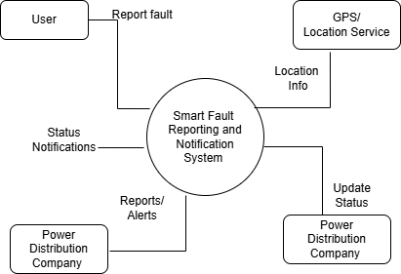

Fig. Context Diagram for Smart Fault Reporting and Notification System

2. Sequence Diagram – Illustrates interactions during fault reporting and technician assignment.

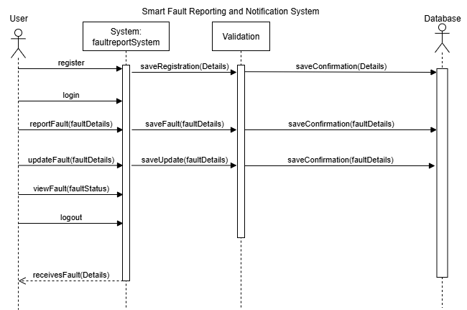

Fig. Sequence Diagram for Smart Fault Reporting and Notification System

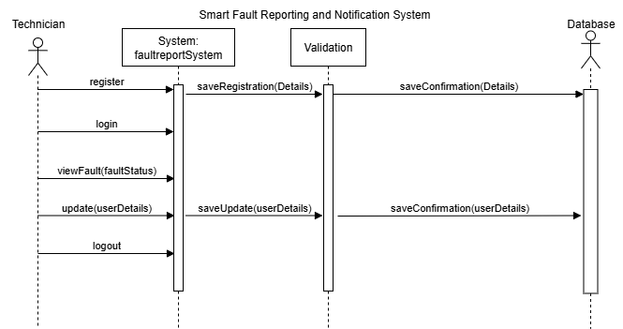

1. Class Diagram – Defines system components such as User, Fault, and Notification.

Fig. Class Diagram for Smart Fault Reporting and Notification System

4.This is a Use Case Diagram. A use case diagram is used to visually represent the interactions between users (actors) and a system. It shows what the system does (its functionalities) from the user’s perspective, not how it does it. In the use case diagram for the **Smart Fault Reporting and Notification System**, the **Admin** is responsible for managing and maintaining customer information within the system, the Admin can **check fault status** submitted by customers. The admin can **log in** securely to access the system, **view fault details** to understand the nature and location of the problem and has the ability to **update customer data**, such as correcting user details or managing records related to fault reports. This role ensures that the system operates smoothly by keeping the customer database accurate and up to date. While the admin does not report or check faults like the user, their actions are crucial for backend operations and data integrity, which support the efficient functioning of the entire fault management system.

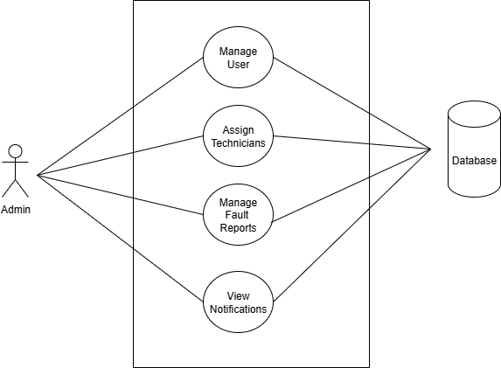

Fig. Use Case Diagram for an Administrator

In the use case diagram for the **Smart Fault Reporting and Notification System**, the **Technician** is a key actor responsible for handling reported faults. The technician can **log in** to the system to securely access their dashboard, where they can **check fault status** submitted by customers, **view fault details** to understand the nature and location of the problem, and **update customer information** if necessary such as providing resolution notes or confirming repairs. These actions are directly connected to the system's **database**, ensuring all updates are recorded in real time. The technician plays a crucial operational role by diagnosing and responding to faults efficiently, helping to ensure fast resolution and improved power distribution service.

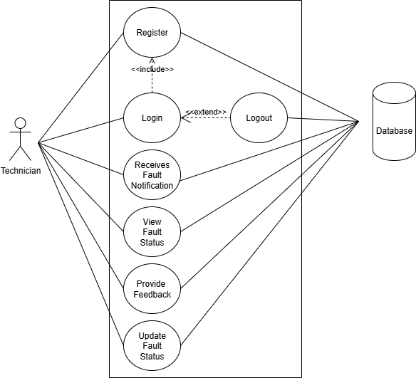

Fig. Use Case Diagram for a Technician

In the use case diagram for the **Smart Fault Reporting and Notification System**, the **User (Customer)** is the primary actor who interacts with the system to report and track electricity-related faults. The user can **register** to create an account and then **log in** to access system features. Once logged in, they can **report a fault** when they experience an issue with power supply, and **update fault information** if there are changes or additional details. Users can also **view the status** of reported faults, **receive fault details** to stay informed about the progress of resolution, and **receive notifications** sent by the system or technicians, such as repair updates or restoration times. All these interactions are tied to the central **database**, ensuring that fault data and user records are accurately stored and managed. This empowers customers with transparency and real-time communication, improving satisfaction and trust in power service delivery.

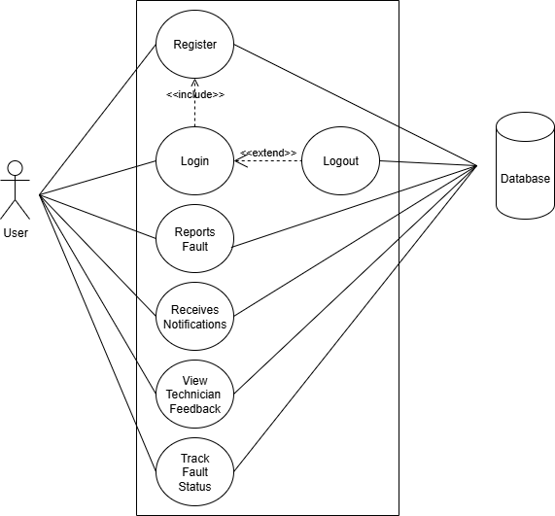

Fig. Use Case Diagram for a User

**3.5.3 NEW FEATURES OF THE PROPOSED SYSTEM**

Key features introduced include:

1. Real-time fault reporting and status tracking

2. Technician alert via automated email

3. Role-based access control (Admin, Technician, Customer)

4. Dashboard views with fault analytics

* + 1. **DEVELOPMENT TOOLS AND ENVIRONMENT**

1. Frontend: HTML, CSS, JavaScript

2. Backend: PHP

3. Database: MySQL

4. IDE: Visual Studio Code

5. Server Environment: XAMPP (Apache, MySQL, PHP)

* + 1. **REVIEW OF GOOD FEATURES**

1. Easy-to-use interface for customers and staff

2. Faster fault resolution via technician notifications

3. Improved monitoring through admin dashboards

* + 1. **REVIEW OF BAD FEATURES (IF ANY)**

1. Requires internet access, which may limit some users

2. Technician dispatch is manually managed

3. Currently web-only; lacks mobile or SMS-based features

**3.5.7 SUMMARY OF THE SYSTEM REVIEW**

The proposed system significantly improves fault communication and resolution through real-time reporting and feedback. Although limited to internet-based access in its current version, the system lays the foundation for scalable, efficient fault management across Ghana’s power grid.